Collaborative Development Database Documentation

1. EMP
2. OFFICE
3. COM
4. CUST
5. GAMES
6. PAYMENT
7. PROD
8. STOCK
9. PRODUCTS
10. Comment
11. Creed-comment
12. Wholesale

Db1007022:

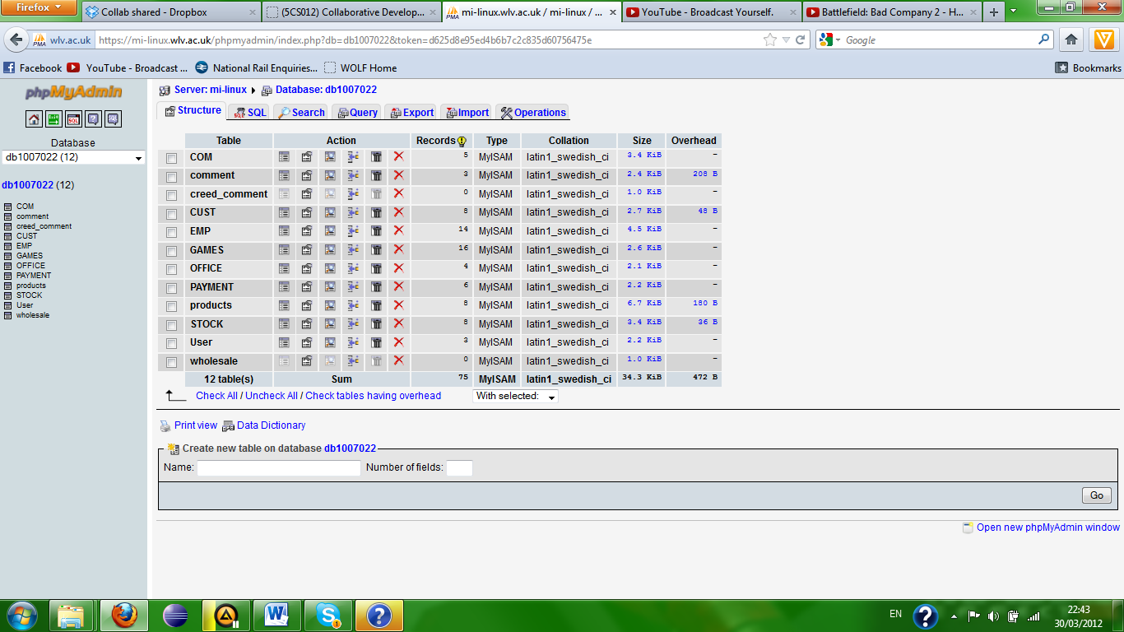

This is the structure of the database, it is used by the website and the backoffice to hold all of they’re data securely and efficiently.

EMP:

EMPNO (employee number), is a unique integer assigned to each employee, it is the primary key of this table.

ENAME (employee name), is a varchar detailing the surname of the employee.

JOB is a varchar detailing the name of the employees job.

ACCLVL (access Level), is an integer detailing the employee’s access level.

ETELNO (employee telephone number), is an integer detailing the employees home phone number.

EMOBNO (employee mobile number), is an integer detailing the employees mobile number, this can be null.

EEMAIL (employee email), is a varchar detailing the employees email address.

EPASS (employee password), is a varchar detailing the employees password.

ESEQ (employee secret question), is a varchar detailing the employees secret question to be used if they forget they’re password.

ESEA (employee secret answer), is a varchar detailing the employees secret answer to be used if they forget they’re password.

OFFICENO (office number), is an integer detailing which office/department the employee comes from, this is a foreign key from the office table.

SAL (salary), is an integer which shows the employees salary.

HIREDATE, details the date the employee was hired.

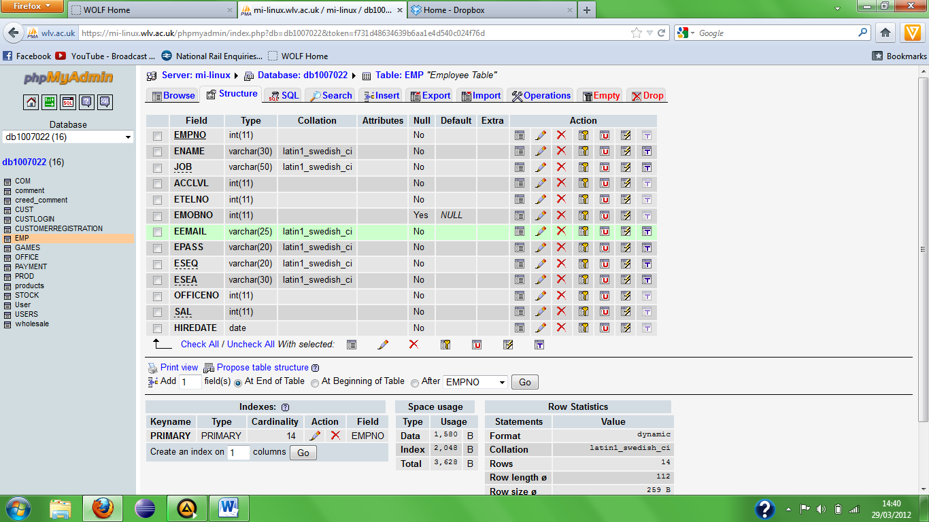

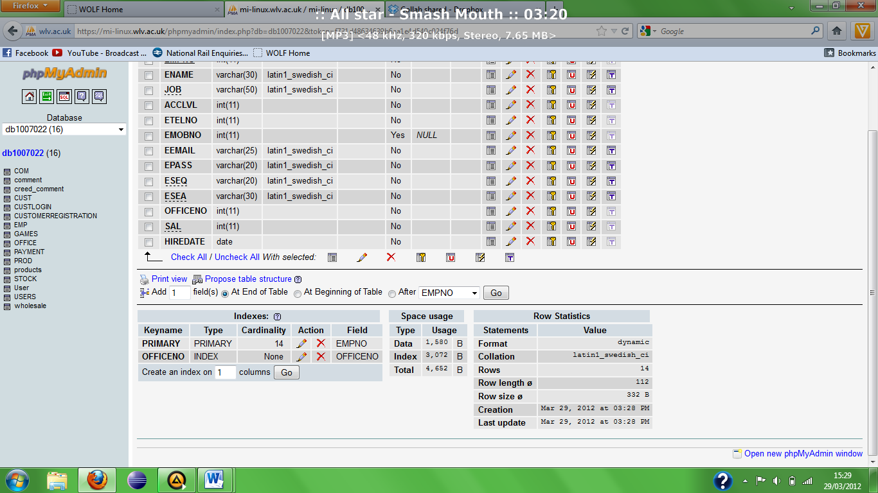

This is the structure of the EMP table which holds all of the employee’s details.

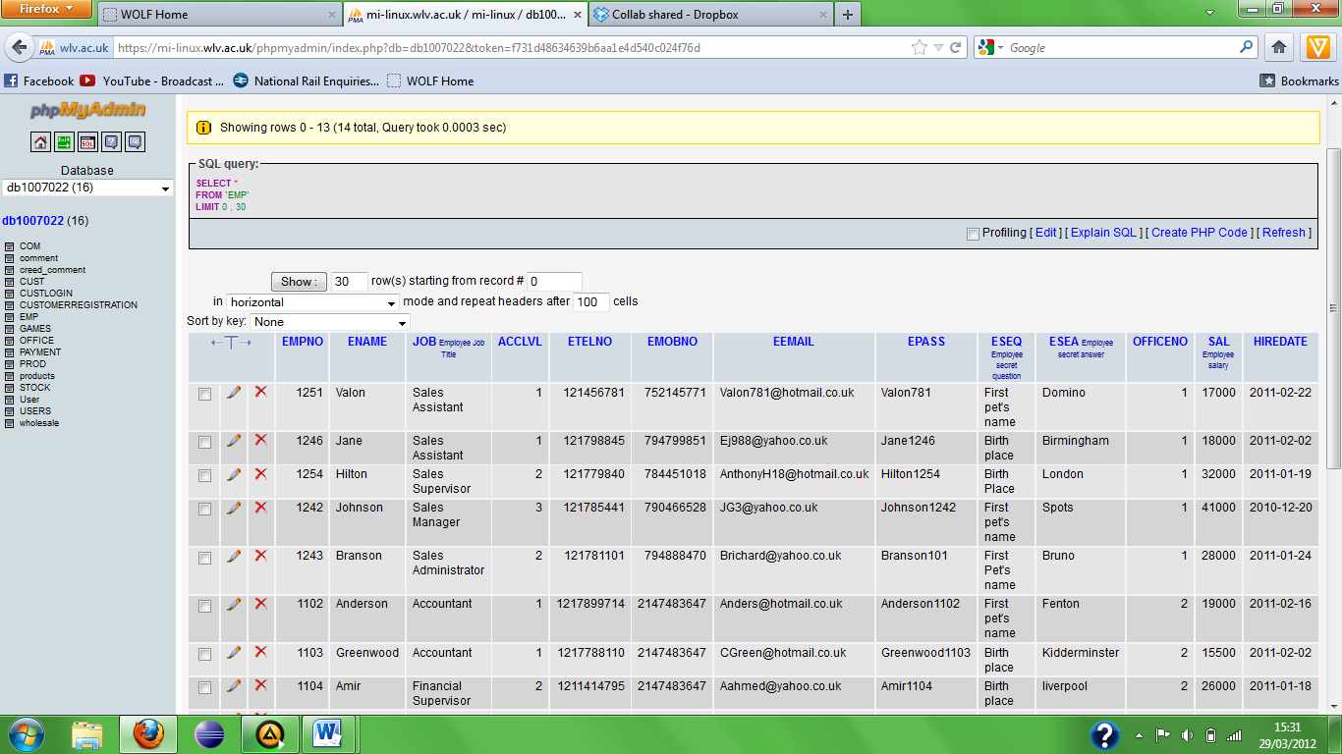

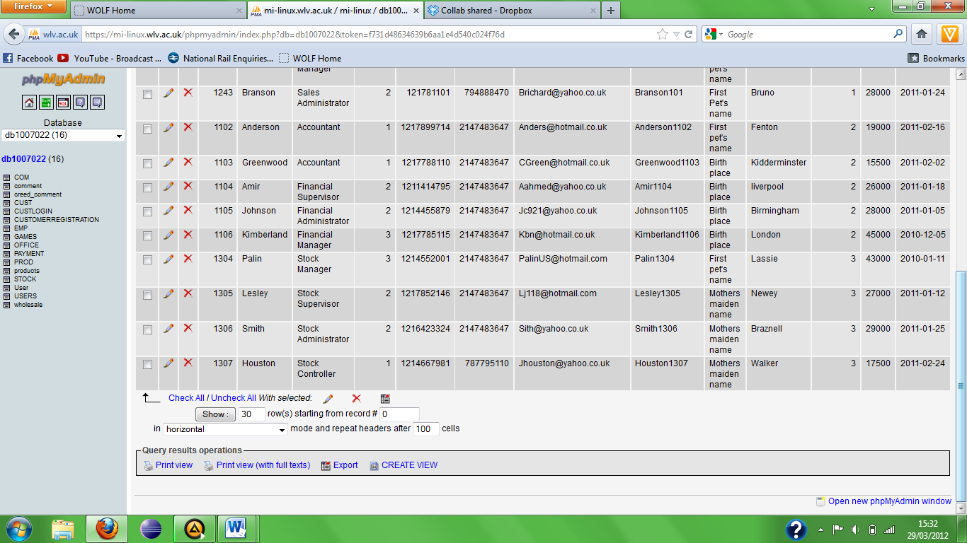

Here is the EMP table with all of the employee’s details inside of it.

OFFICE:

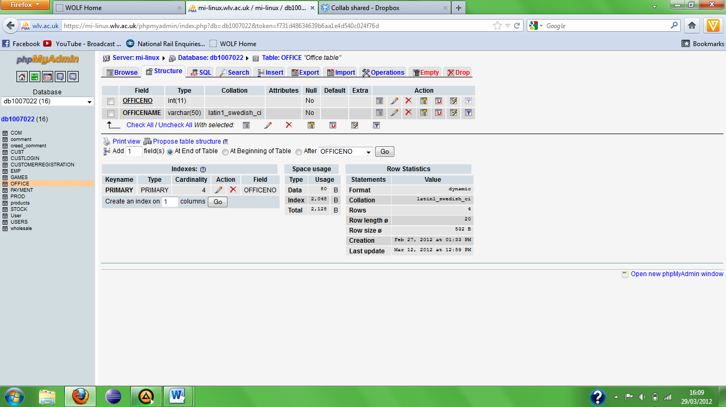

OFFICENO (office number), this is an integer which details the office/department numbers; this is the primary key of the table.

OFFICENAME, this is a varchar detailing the names of the offices/department’s.

This is the structure of the OFFICE table which is used to link to the EMP table, with details about all the department’s in the database.

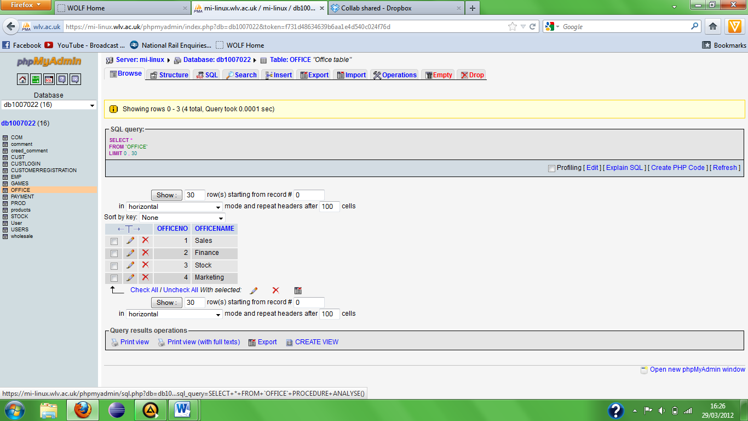

Here is the OFFICE table with all of the office/department’s details inside of it.

COM:

COMNO (company number), this integer uniquely represents a company; this is the primary key of the table.

COMNAME (company name), this varchar details the company’s name.

COMADD (company address), this varchar details the company’s address.

COMTEL (company telephone number), this integer details the company’s telephone number.

CONTNAME (contact name), this varchar details the name of the contact name for the company’s.

CURRSTCK (current stock), this varchar details the current stock level of the product supplied by the company.

CURRINV (current invoice), this varchar shows the current invoice details of the company’s.

DELHIST (delivery history), this varchar details the delivery histories of the company’s.

PRODID (product id), this integer uniquely identifies a product supplied by the companies, this is a foreign key from the prod table.

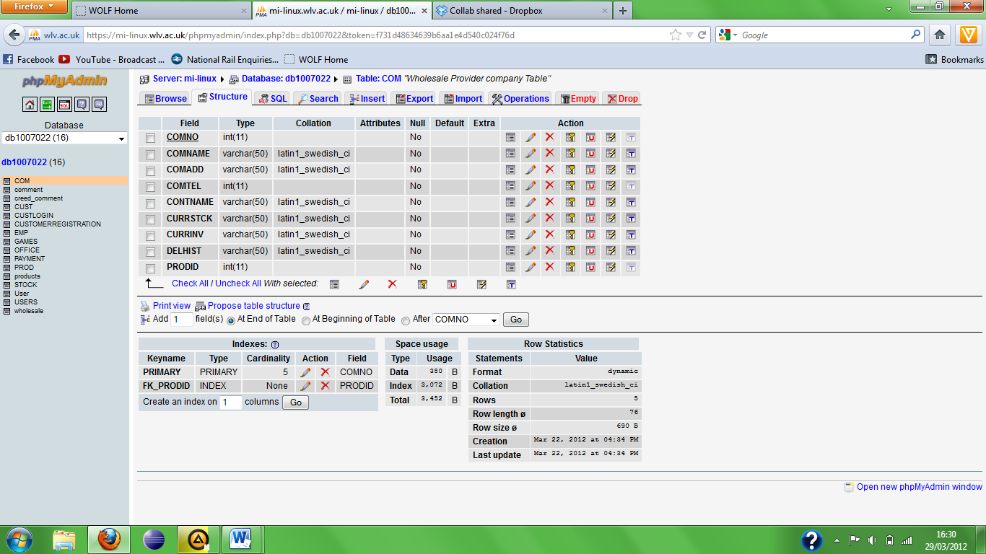

This is the structure of the COM table which holds all of the suppliers details.

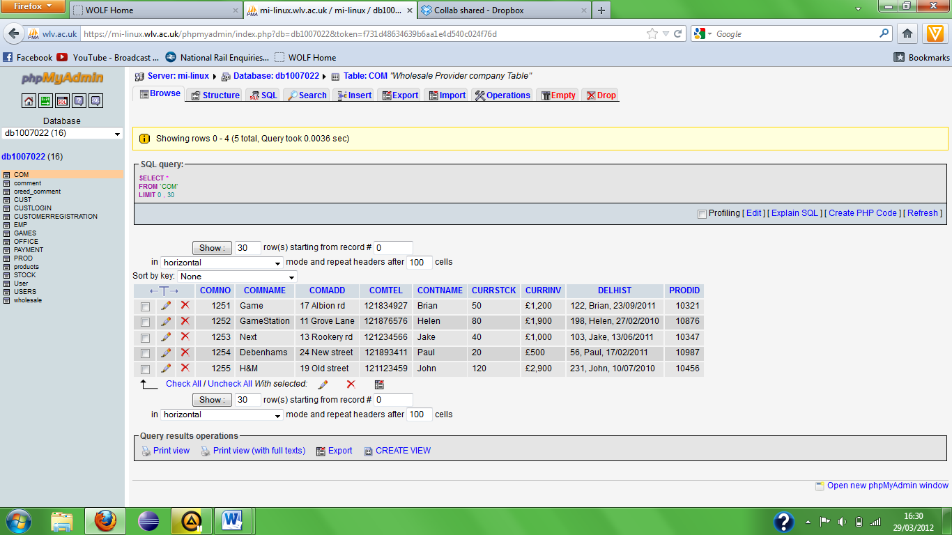

Here is the COM table with all of the company’s details inside of it.

CUST:

CUSTNO (customer number), this integer uniquely identifies the customer’s; this is the primary key of the table.

CNAME (customer name), this varchar details the customer’s surname’s.

CTELNO (customer telephone number), this varchar details the customers home phone number.

CMOBNO (customer mobile number), this varchar details the customers mobile phone number; this can be null.

CADD (customer address), this varchar details the customer’s address.

CEMAIL (customer email address), this varchar details the customers email address.

CPAY (customer payments), this integer details the customer payments.

PURHIST (purchase history), this integer details the history of the customer’s payments.

LYLSTAT (loyalty status), this integer details the status of the customers loyalty points based on how many and size of payments.

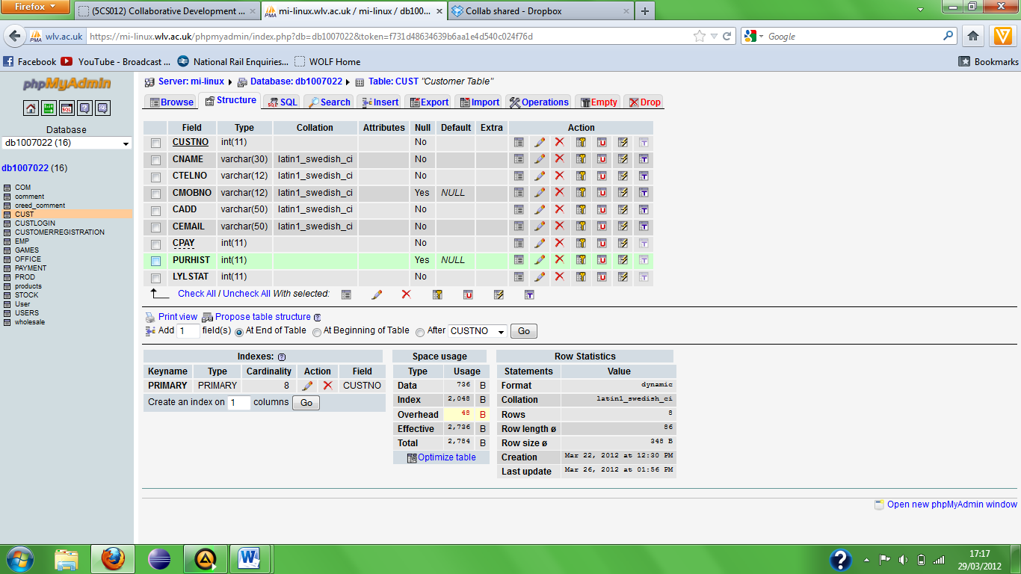

This is the structure of the CUST table which holds all of the

Customers details.

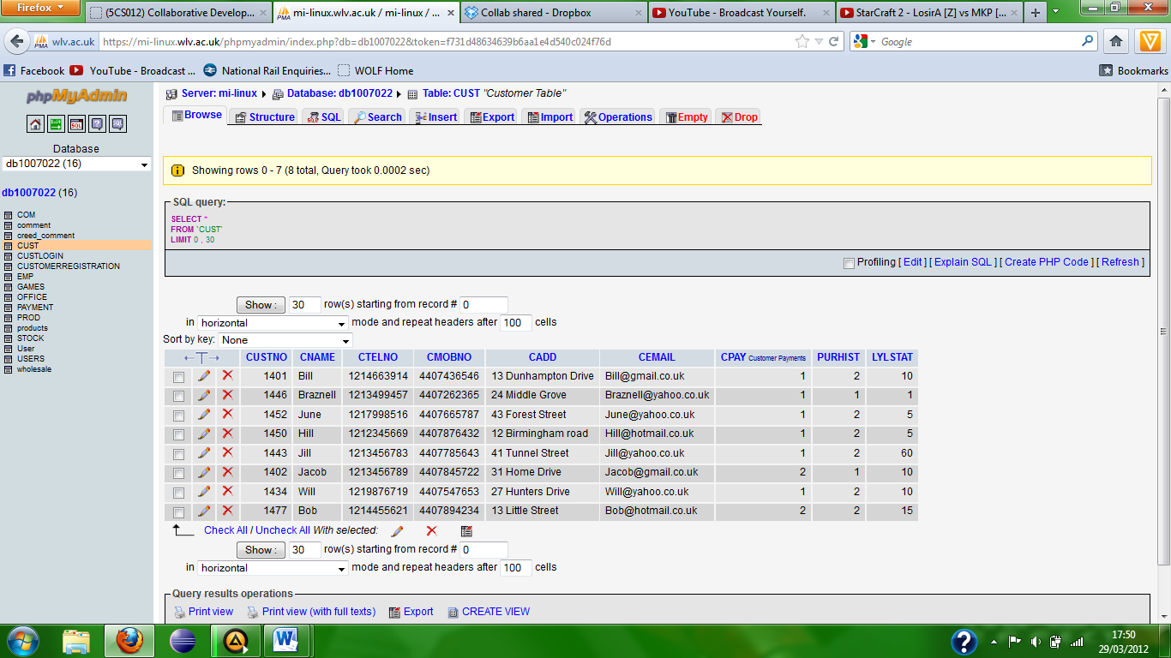

Here is the CUST table which holds all the customer details inside of it.

GAMES:

Id, this varchar uniquely identifies the games; this is the primary key of the table.

Title, this varchar details the games names.

Author, this varchar details the games authors.

Price, this integer details the games price.

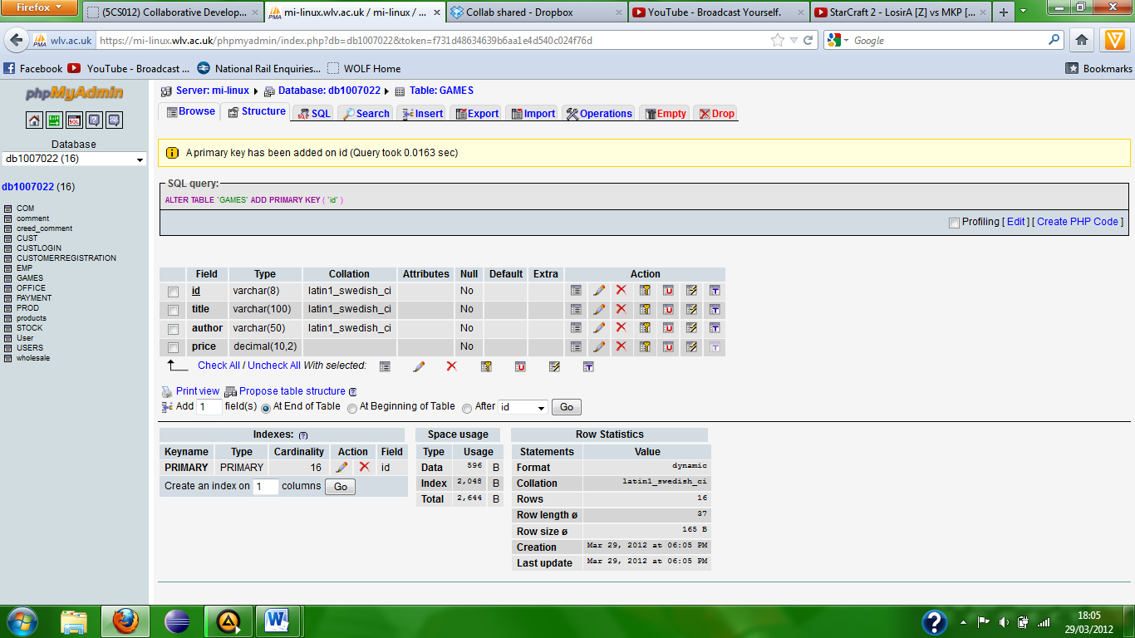

This is the GAMES table which holds all the games/software details inside of it.

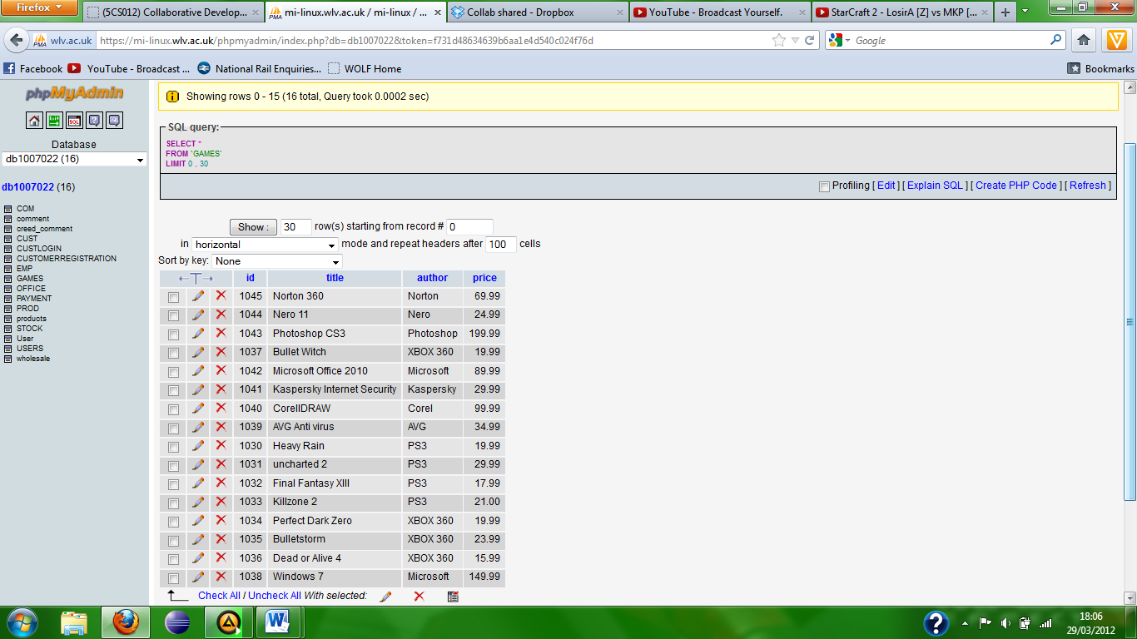

Here is the GAMES table which holds the games/software details inside of it.

PAYMENT:

PaymentID, this varchar uniquely identifies the payments; this is the primary key of the table.

FirstName, this varchar details the customer’s first name.

Surname, this varchar details the customer’s last name.

ItemName, this varchar details the item to be purchased.

ItemType, this varchar details the type of item to be purchased.

CreditCardNumber, this varchar details the credit card number to be used in payment.

Security, this varchar details the 3 digit security code on a credit card.

Expiry, this details the date of when the credit card expires.

Telephone, this varchar details the telephone number of the customer making a payment.

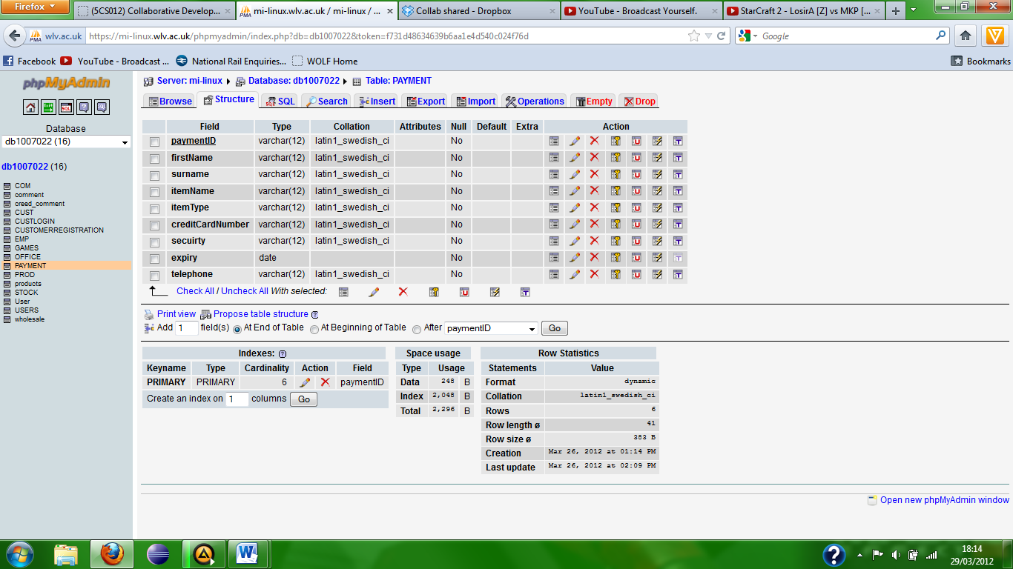

This is the structure of the PAYMENT table which holds all the customers

payment details inside of it.

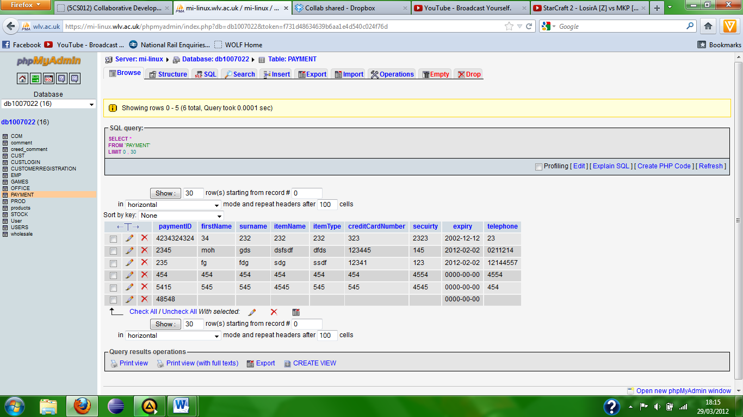

Here is the PAYMENT table which holds all the customers payment details inside of it.

PROD:

PRODID (product id), this integer uniquely identifies the products; this is the primary key of the table.

PRODNAME (product name), this varchar details the products name.

CONSOLE, this details which console the product is on.

DATEORD (date ordered), this details the date the product was ordered.

DATEDEL (date delivered), this details the date the product was delivered.

PRODPRICE (product price), this decimal details the price of the products.

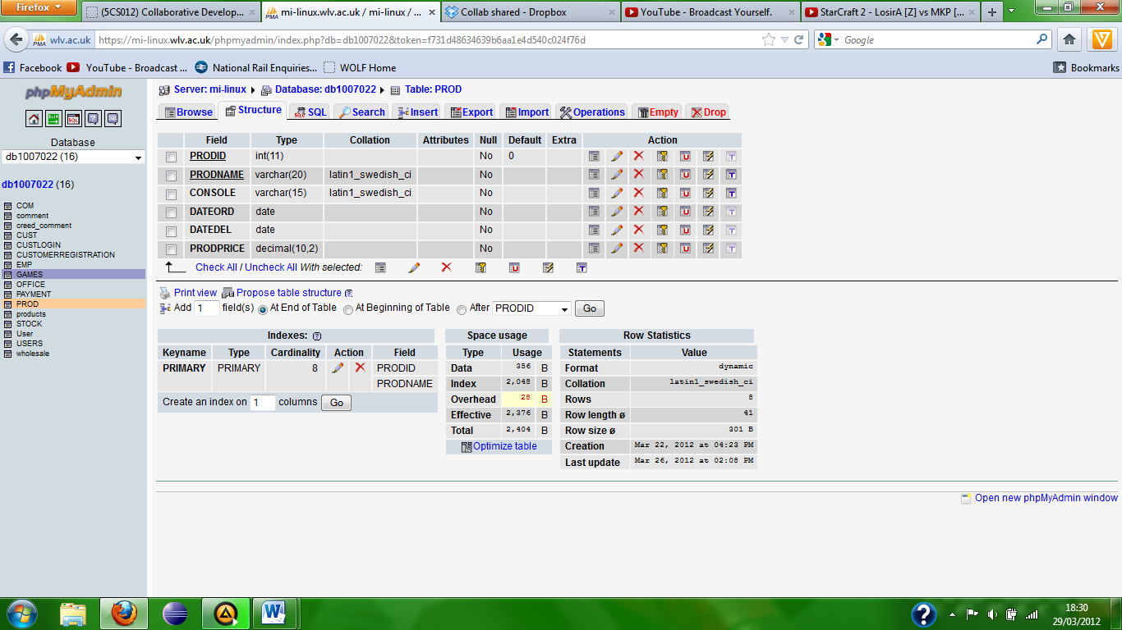

This is the structure of the PROD table which holds all the products details inside of it.

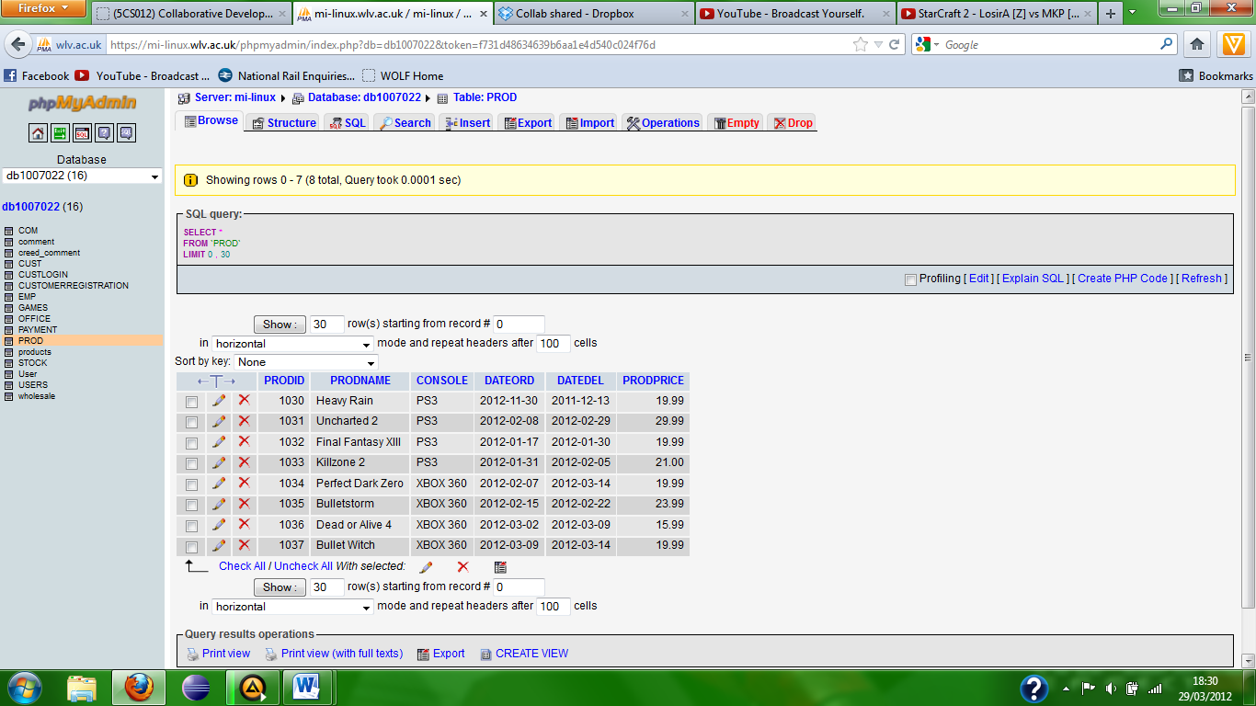

Here is the PROD table which holds all the products details inside of it.

STOCK:

STOCKNO (stock number), this integer uniquely identifies the products; this is the primary key of the table.

PRODNAME (product name), this varchar details the name of the products; this is a foreign key from the prod table

CREVIEW (customer review), this varchar details the reviews the customers gave the products.

NOSLA (number of sales since last audit), this varchar details the number of sales since the last audit a product had.

OFFER, this varchar details the offers the products have for them.

AMSTOCK (amount in stock), this integer details the amount of the products that are in stock.

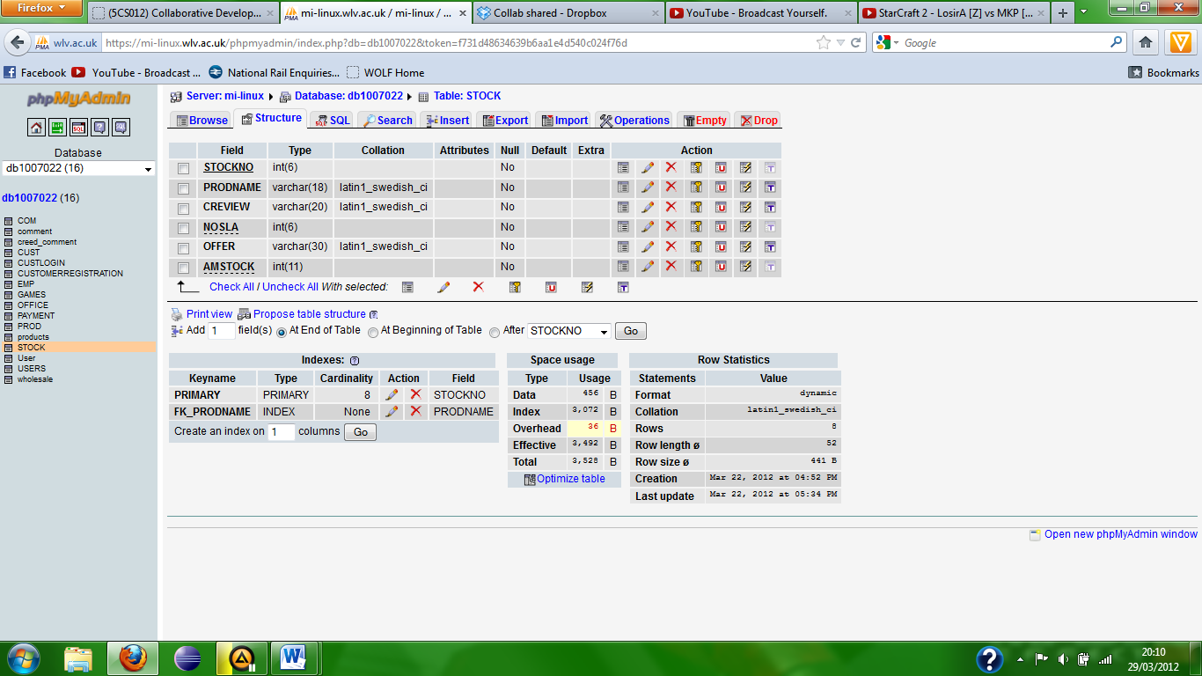

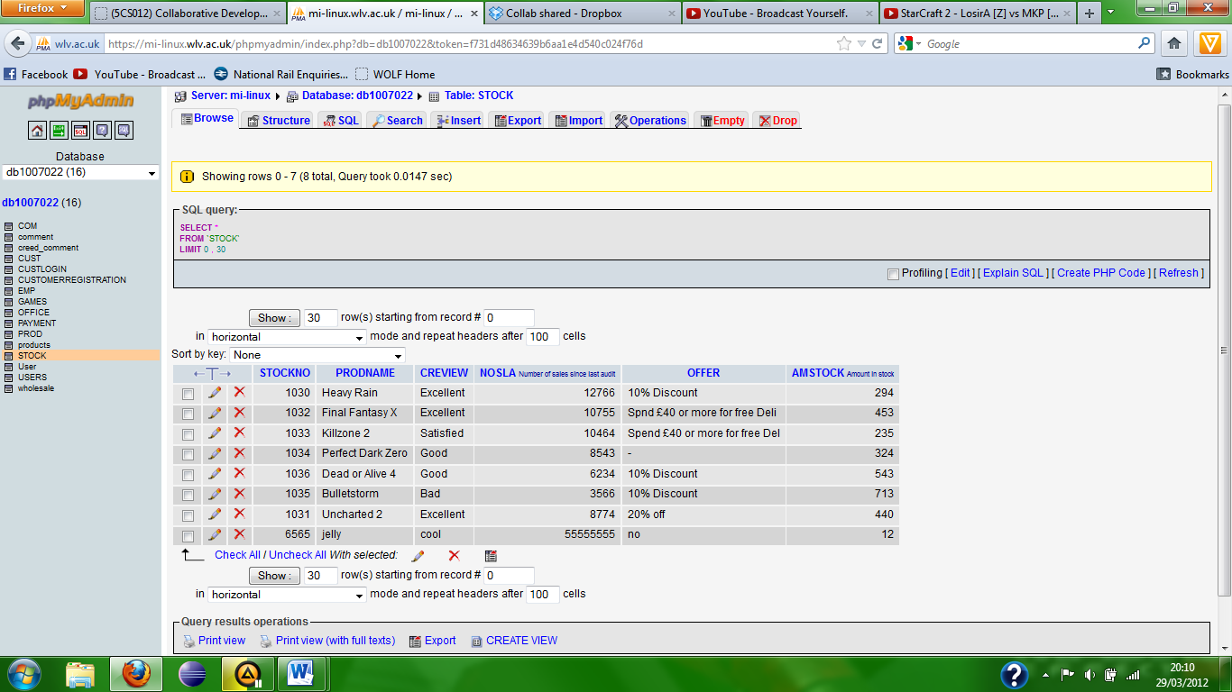

PRODUCTS:

id (product id), this integer uniquely identifies the products; this is the primary key of the table.

name (product name), this varchar details the products name.

description, this varchar gives a description of the products.

price, this float details the price of the product.

Shipping (shipping costs), this float details the cost of shipping.

quantity (product quantity), this integer details the quantity of the products.

pic (picture), this varchar details a link to a picture used in the website.

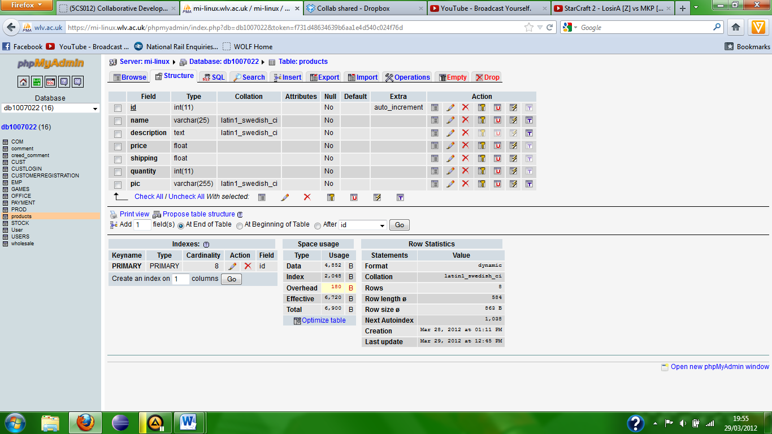

This is the structure of the PRODUCTS table which holds all the products details inside it.

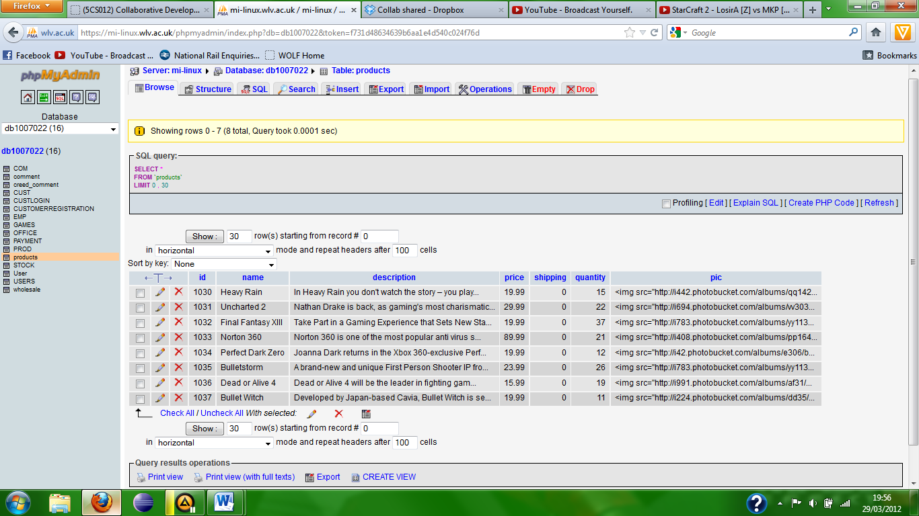

Here is the PRODUCTS table which holds all the products details inside of it.

Comment:

id (customer id), this integer uniquely identifies the customers; this is a foreign key from the CUST table.

name (customer name), this varchar details the customers name.

comment, this text type details the comments the customers make about the products on the website.

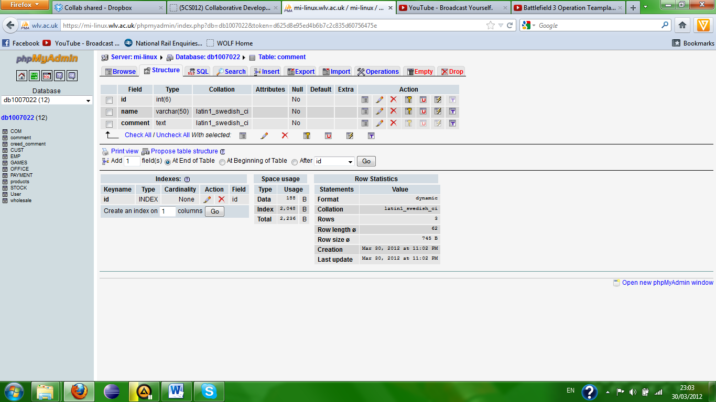

This is the comment table which holds details for customers who commented on products on the website.

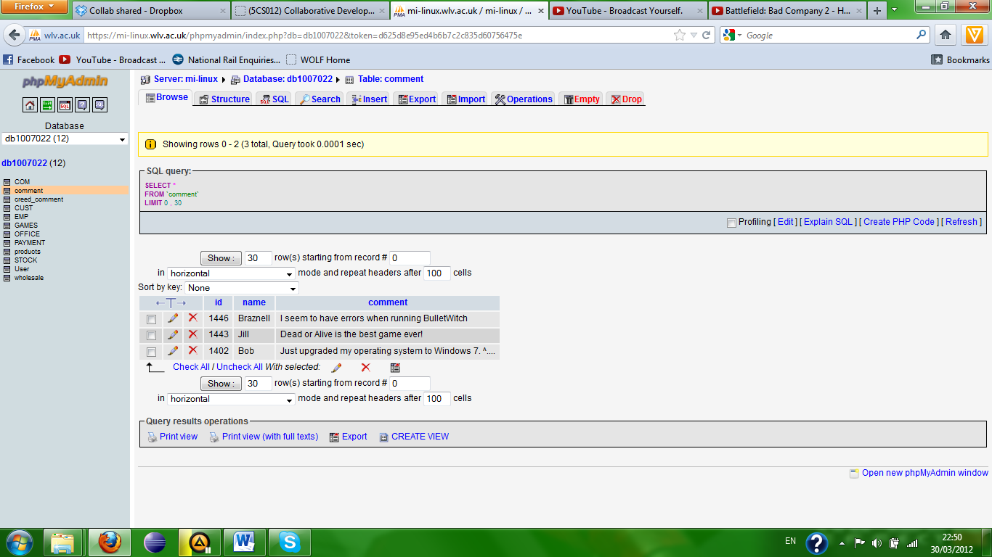

Here is the comment table which holds all the customers comments on the products in the website in the table inside of it.

Creed_comment:

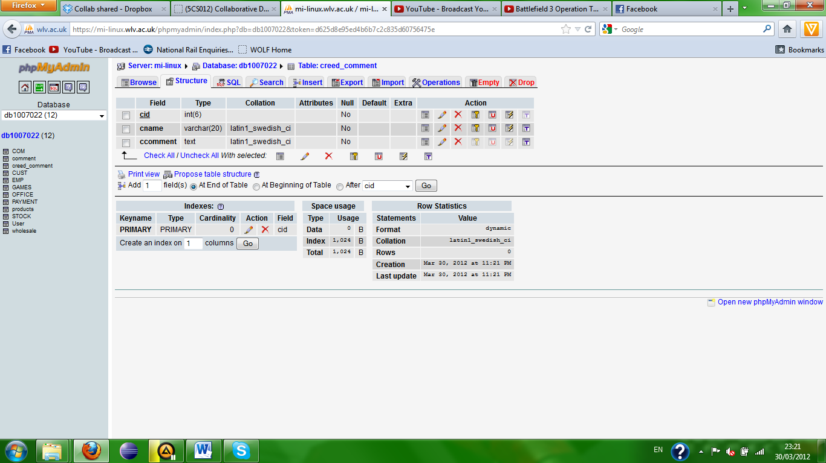

Wholesale id, this integer uniquely identifies the wholesalers; this is the primary key of the table.

name (wholesaler name), this varchar details the wholesalers name.

product type, this varchar details the type of product shown on the website.

Address, this varchar details the address of the wholesaler’s.

City, this varchar details the city the wholesaler’s are based.

Postcode, this varchar details the wholesaler’s postcode.

Wholesale:

